M01 Chapter 1 Hands On Projects
1-1: Install Wireshark
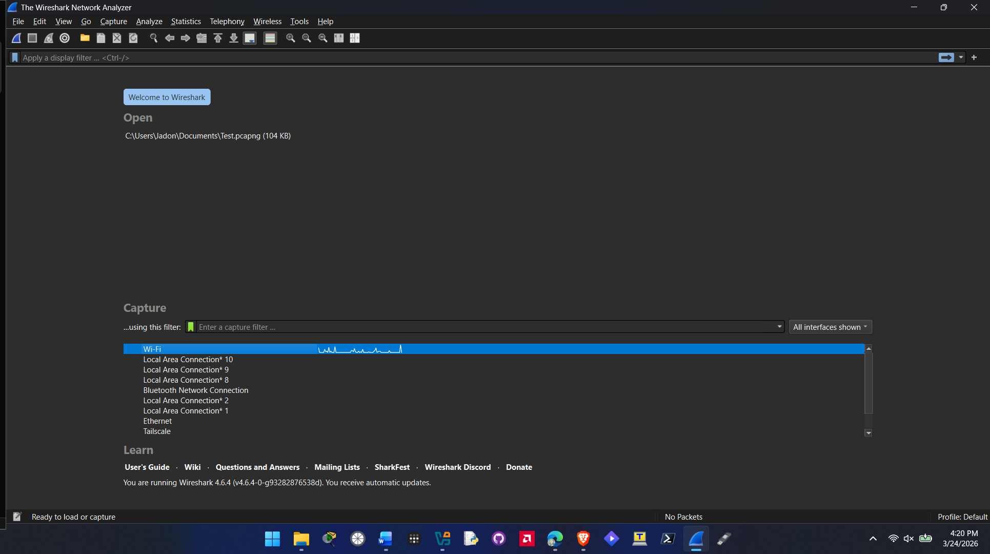

1-2: Capture Basic Packets and Explore Basic Packets and Statistics
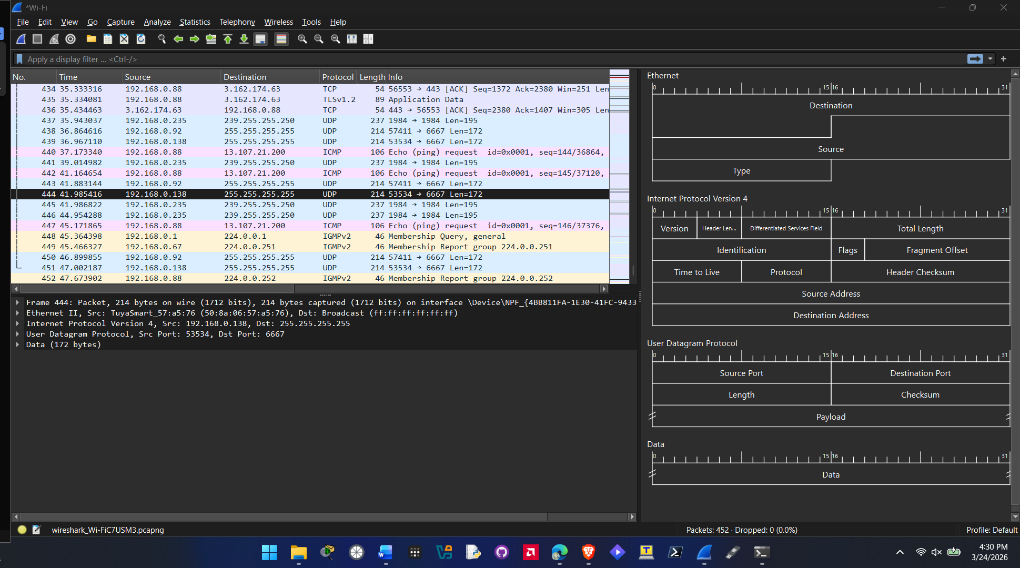
Question 12.
Yes, I recognize my IP address on my home network. Its 192.168.0.88. Yes I can also see some broadcast addresses. 255.255.255.255 is displayed under multiple UDP packets.
Question 14.
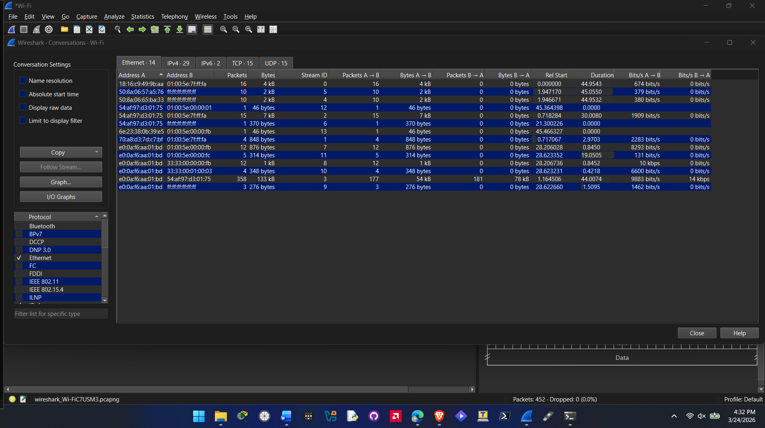
Question 16.
The packet size that is most common in my trace buffer are IPv4 packets listed at 8692 bytes.
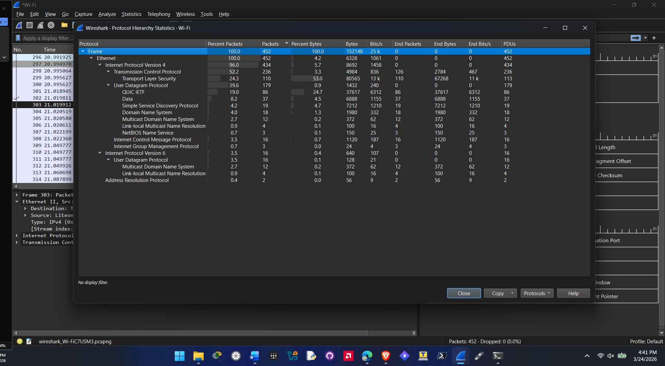
Question 17.
The types of communication seen in the trace buffer is all encrypted data and its listed in hexadecimal format in some areas. There is some website information listed in some of the TCP packets. In some of the UDP packets some server information can be made out too.
Question 18.
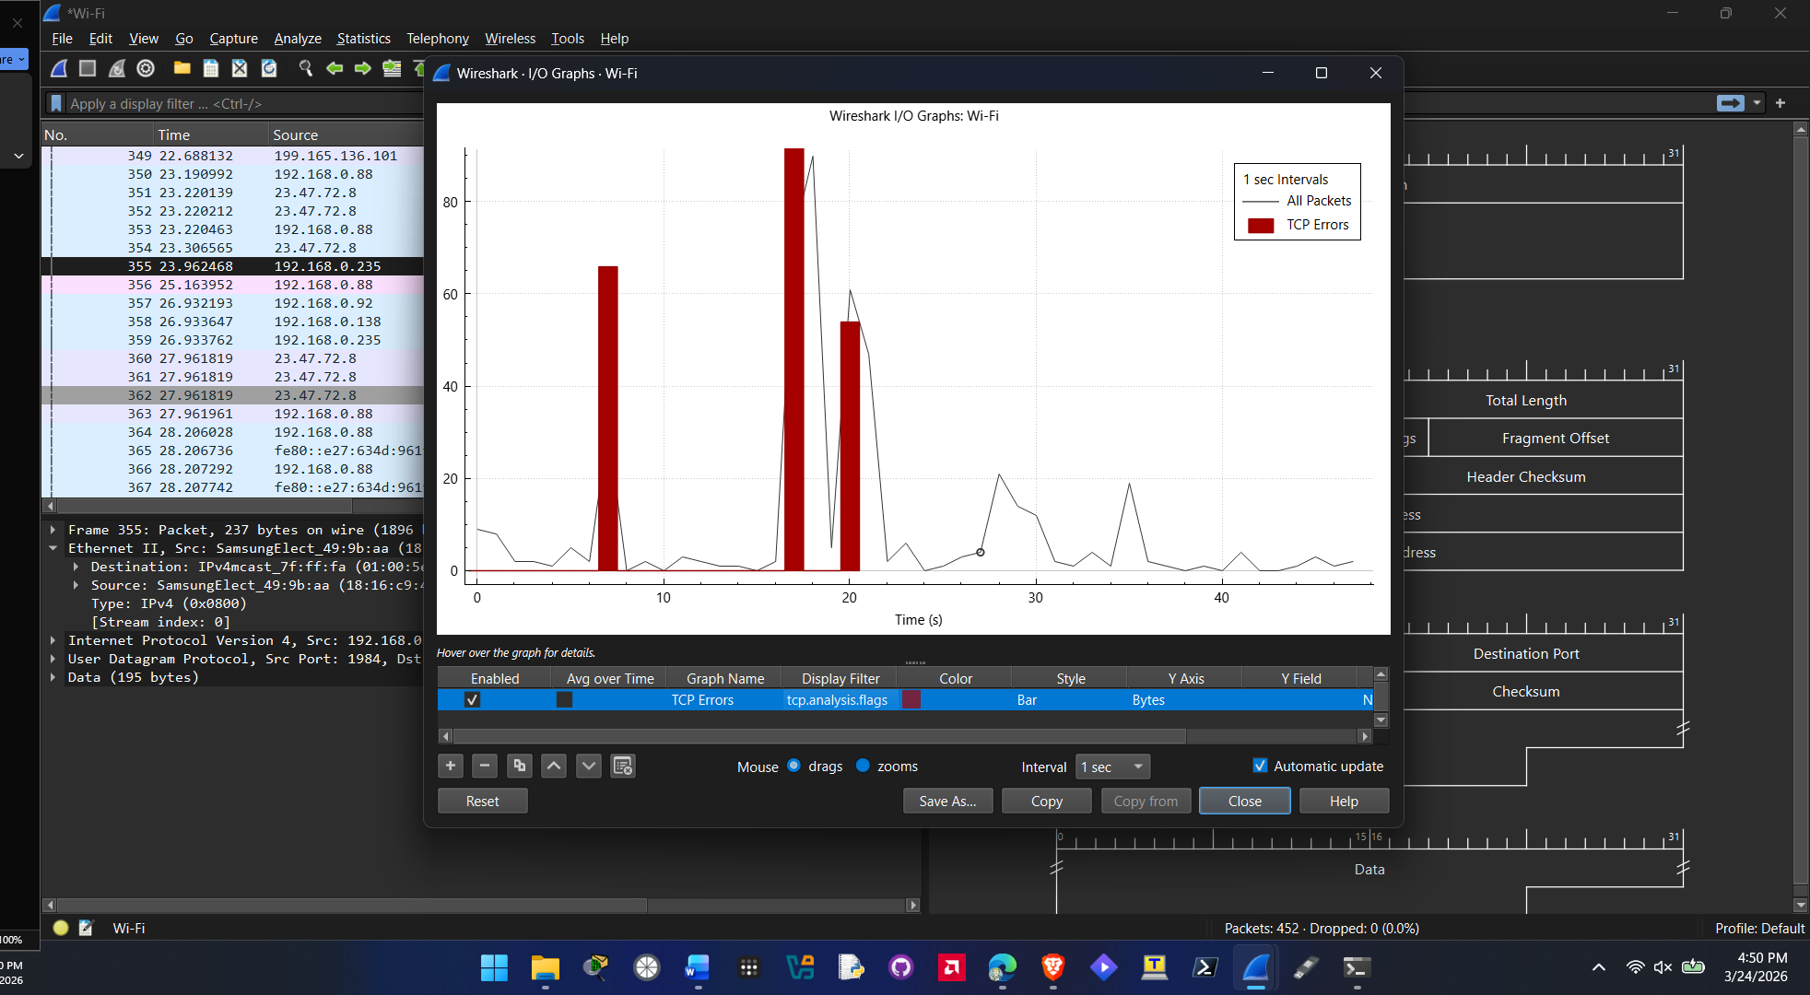

1-3: Select a Filter and Capture Packets
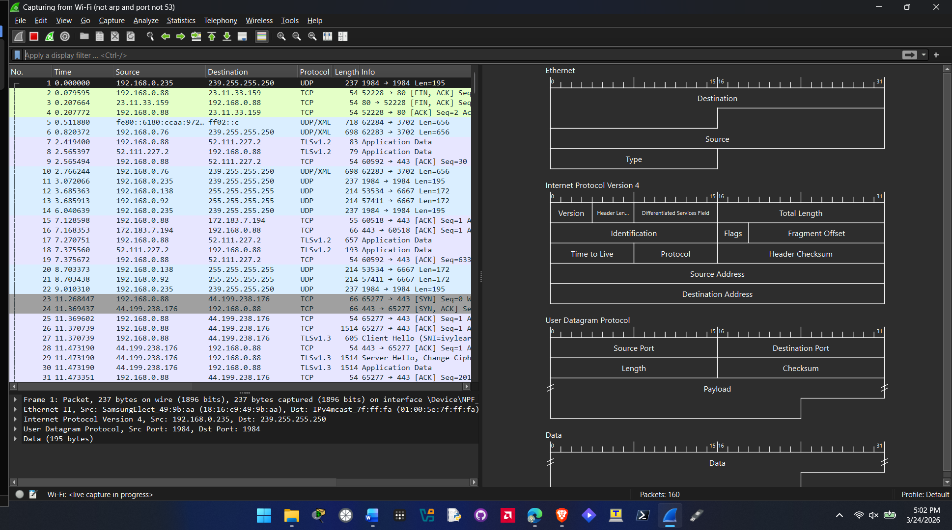

1-4: Create a Display Filter
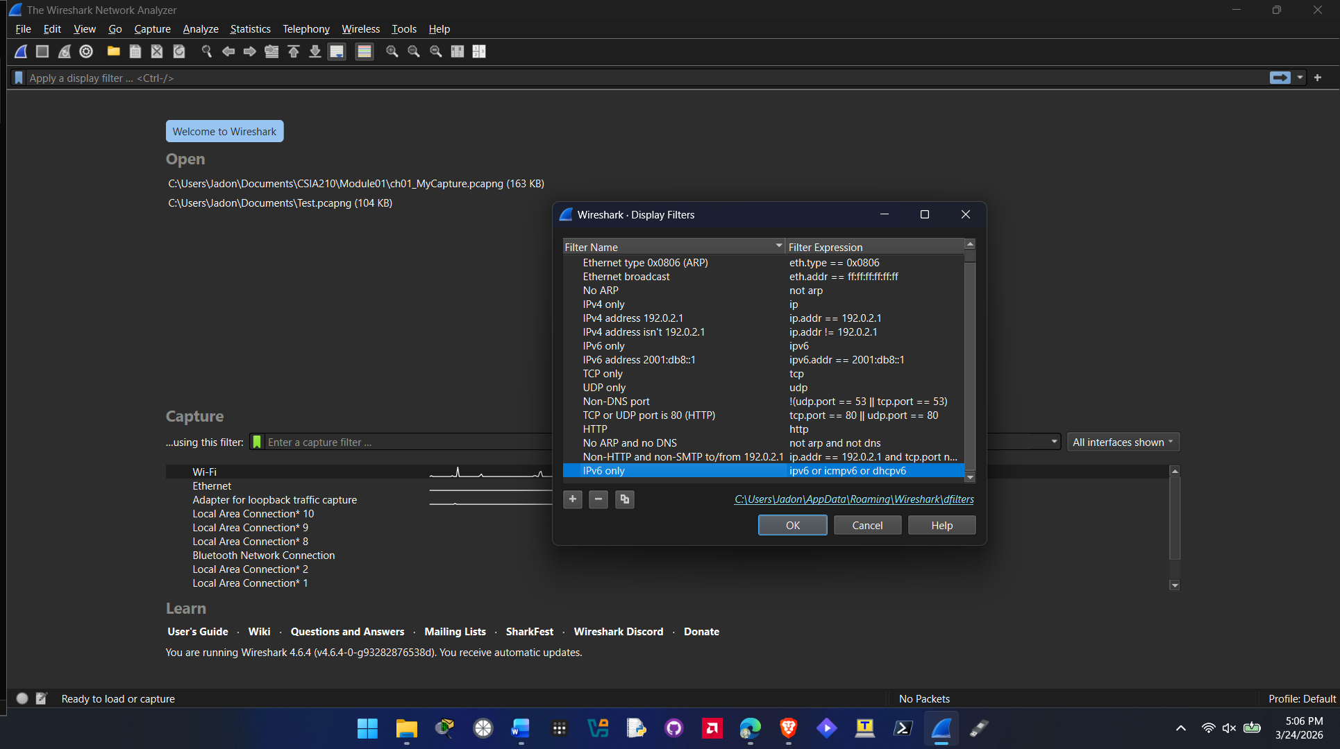

1-5: Examine a Complete Packet Decode
